Nuclear reactions in condensed matter

Fulvio Frisone
Department of Physics, University of Catania,
Via Santa Sofia 64, I-95123 Catania, e-mail, frisone@ct.infn.it

Abstract
This paper focuses on the main features of the tunneling between two deuterons within a lattice. Considering a “screening effect” due to lattice electrons, d-d fusion rates are compared as evaluated from different authors, assuming different screening efficiency and different d-d potentials.
Further, an effective potential is proposed which describes very well the attractive contribution due to plasmon exchange between two deuterons. By means of this, d-d fusion rates are computed for different energy values. Finally, a good agreement between theoretical values and experimental results proves the reality of cold fusion phenomena and the reliability of the model which is presented here.
The coherence model of condensed matter affirms that within a deuteron-loaded palladium lattice there are three different plasmas: electrons, ions and deuterons plasma.

I. Introduction

The first cold fusion phenomenon has been observed in the 1926 by Paneth and Peters that passed H₂ through a high temperature Pd capillary tube and observed He spectral line [1]. Of course this episode doesn’t sign the rise of a new branch of science since they, subsequently, declared that the helium was released from the heated glass container. Then, for about 60 years, nobody spoke about low energy nuclear reaction, until, on March 23, 1989, Fleischmann and Pons declared the achievement of a deuterons fusion at room temperature in a Pd electrolytic cell using D₂O [2].
Since their discovery, a large amount of efforts have been spent in order to reproduce the fusion but actually the experimental knowledge and the know-how is not so far robust. However the evidence of anomalous nuclear phenomenon had been built up in these last years [3-6].
In this paper we want to summarize some theoretical efforts in order to understand the probably mechanism of cold fusion. In particular we focus on tunneling traveling of coulomb barrier existent between two deuterons. More exactly it will be analyzed the possible contributions of lattice in order to enhance of tunneling probability and, in this way, we will find that there is a real mechanism by means of which this probability is a lot increased: this mechanism is the screening effect due to d-shell electrons of palladium lattice.
Finally it will demonstrate that the cold fusion can be understood within a special theoretical framework which involves lattice interference on nuclear reactions but doesn’t imply any conceptual revisions of modern physics knowledge.

II. Tunneling in molecular D₂

After the nuclear disintegration had been discovered, it soon became clear that the laws of classical dynamics were not able to reproduce some experimental regularities as the radioactive decay law. This law involves that the time of disintegration of an atom is as independent of the previous history and of its physical condition, in other words the behavior of particles is governed by probability. Gamow [7] demonstrated that using the Copenhagen interpretation of Scrödinger equation it was possible to obtain the correct decay law expression. In this way the tunnel effect was universally accepted. Actually we are not able to understand transmutation and disintegration phenomena without the no-classical traveling of potential barrier.
In this time, the tunneling effect is a very important statement of physics ‘behavior’ of microscopic particles; for example a very lot of the microelectronic devices as flash memories [8] base oneself on Fowler-Nordheim tunneling.
Now, established the fusion process in terms of penetration of a particle of energy E in a region classically forbidden whose potential is V, the fusion reaction rate Λ (sec⁻¹) will be determined, according to quantum mechanics, from the following expression:

$Λ=A{\left|ψ\left(r_{o}\right)\right|}^{2}$ (1)

Here A is the nuclear reaction constant obtained from measured cross sections, the probability ${\left|ψ\left(r_{0}\right)\right|}^{2}$ is the square modulus of the inter-particles wave-function, and r₀ is the point of forbidden zone. Finally it is demonstrated that for a Coulomb potential:

${\left|ψ(r_{0})\right|}^{2}=\left|\frac{k\left(r_{e}\right)}{k(r_{0})}\right|\text{exp}\left\{−\frac{2}{ℏ}\int_{r_{0}}^{r^{'}}{\sqrt{2μ\left(V−E)\right)}\text{dr}}\right\}$ (2)

where

$k(r)=\frac{\sqrt{2μ\left(V(r)−E)\right)}}{ℏ}$ (3)

and r’ is the classical turning point.
Here μ is the mass of particle incoming, r₀ is a point within forbidden region, E is the energy of particle, and k(r_{e}) is the wave number of the zero point oscillation:

$\frac{ℏ^{2}k^{2}(r_{e})}{2μ}=E$ (4)

Of course the pre-factor of exponential is about 1 and the exponential term is know as Gamow-amplitude. More exactly we define as Gamow-factor:

$η_{G}(r_{0})=\text{exp}\left\{−\frac{1}{ℏ}\int_{r}^{r_{0}}{\sqrt{2μ\left(V−E)\right)}\text{dr}}\right\}$ (5)

Now compute the fusion probability between two nuclei of D₂ molecular. In this case we must consider that the average distance between two deuterons, within the D₂-molecule, is $r_{0}≈0\text{.}\text{74}\overset{0}{A}$ while the distance at which the nuclear force takes place is r ≈ 20 F. Then if we put V=α/r, i.e. the coulomb potential, and with μ label the reduced mass, we’ll compute k ≈ 1. Finally for E ≈ 0 we can evaluate:

$η_{G}(r)=\text{exp}−\left\{\sqrt{8\text{αμ}}\left(r_{0}^{1/2}−r^{1/2}\right)\right\}≈{\text{10}}^{−\text{60}}$ (6)

Using A=10²² sec⁻¹, we obtain Λ=10⁻⁹⁸ sec⁻¹.
It means that no detectable process can take place!

III. Deuterons Tunneling as probably cold fusion mechanism

The cold fusion idea came independently to Fleischmann and Pons and to Jones that if deuterium could be forced into palladium, two deuterium nuclei would come so close together as to fuse giving out more power than was being put in. On this case the d-d fusion processes involved are:

$\begin{aligned}1) d+d→\text{He}+n \\ 2) d+d→t+p \\ 3) d+d→\text{He}+γ\end{aligned}$
In the previous section we have computed that the fusion probability between two deuterons within D₂-molecular is very low. But at one time was evaluated in the 1986 that this fusion rate can be reduced [9]. In fact some mechanisms, as the replacing of the electron in a hydrogen molecular ion with a negatively charged muon, are able to increase the reduced mass and then to decrease the Gamow-factor [10] . More exactly, Siclen and Jones, starting from the possibility of creating pressures of several million atmospheres presented by diamond-anvil cell, have considered deuterons fusion rates as function of pressure and, then, of the inter-nuclear distance obtaining an theoretical average fusion rate of 10⁻⁷⁴ sec⁻¹.
They discussed in this way. In a hydrogen molecular the potential has the trend shown in the figure 1. In this case a Morse potential is used in the interval that included the inner turning point r_{a} and continues on toward r=0, near which it is connected with the repulsive Coulomb potential 1/r. The expression is:

$V(r)=D\left[e^{−2γ(r−r_{0})}−2e^{−γ(r−r_{0})}\right]$ (7)

here D is the depth of the potential well that is roughly equal to the dissociation energy and γ is related to the anharmonicity constant which is a measure of the curvature of the Morse potential well.

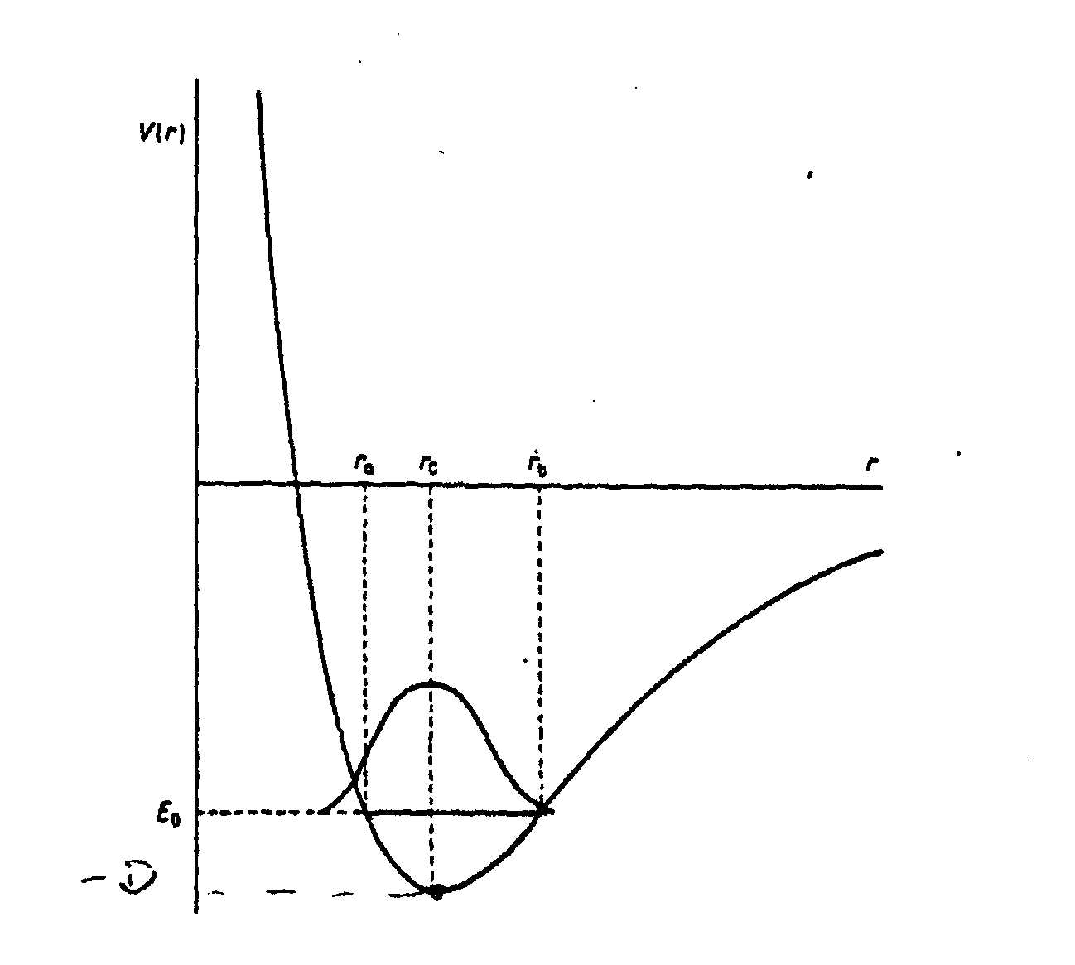
D
Fig. 1

Molecular potential energy curve and ground-state vibrational wavefunction for the relative motion of two nuclei. The points r_{a},r_{b} and r₀ are the classical turning points and the equilibrium inter-nuclear separation, respectively (from ref. 9).

Since the vibrational levels of Morse potential can be written in this way [11]:

$E_{ν}=−D{\left[1−\frac{γℏ}{\sqrt{2μD}}\left(ν+\frac{1}{2}\right)\right]}^{2}$ (8)

it is possible to evaluate by fitting the constant γ and D and r₀. The authors of ref. 9 computed (in units e²/a₀ and a₀=Bohr radius):

D=0.1743 (9)

γ=1.04 (10)

r₀=1.4 (11)

The molecular wavefunction has been evaluated following the method proposed by Langer in the reference 12 which now we will briefly illustrate.
The radial part of Scrödinger equation is:

$\left[\frac{d^{2}}{{\text{dr}}^{2}}+Q_{0}^{2}(r)\right]χ(r)=0$ (12)

where

$Q_{0}^{2}(r)=\frac{2μ}{ℏ^{2}}\left[E−V(r)\right]−\frac{J(J+1)}{r^{2}}$ (13)

and

$χ(r)=rψ(r)$. (14)

The ground v=J=0 molecular wavefunction in the interaction region is thus found to be:

$ψ(r)=\frac{1}{4}{\left(\frac{α^{2}}{π^{3}}\right)}^{1/4}η$ (15)

with

$η=\text{exp}\left\{−\frac{1}{2}\left[\int_{r}^{r_{0}}{\left(2\left|Q(r)\right|−\frac{1}{r}\right)\text{dr}+\text{ln}\frac{r_{a}}{2}}\right]\right\}$$α=\frac{\text{μω}}{ℏ}$ (16)

(17)
and

$Q^{2}(r)=\frac{2μ}{ℏ^{2}}\left[E−V(r)\right]−\frac{(J+1/2)^{2}}{r^{2}}$ (18)

where V(r) is the coulomb potential for r <ρ and the Morse potential for r >ρ being ρ the point at which the Morse potential is connected to the purely Coulomb potential.
Using these results Van Siclen ad Jones demonstrated the possibility of scaling down of repulsive effect between two deuterons. Moreover they showed that the average fusion rate was much more sensitive to the choice of ρ than r (see table 1) .

Table 1
r | ρ | Λ (sec-1)
0 | 0.4 | 3.8 x10⁻⁷⁰
0 | 0.5 | 1.3 x10⁻⁷⁴
10⁻³ | 0.5 | 1.3 x10⁻⁷⁴
10⁻³ | 0.5 | 2.3 x10⁻⁷⁴
10⁻³ | 0.5 | 6.8 x10⁻⁷³
0 | 0.5 | 5.8 x10⁻⁷⁹
Fusion rate evaluated in reference 9 as function of ρ (point where the Morse potential is linked by Coulomb, and r (force nuclear radius). The distance are reported in units of the Bohr radius.

IV. The Screening Effect

As showed in previous section the increasing of deuteron fusion rate is linked to the possibility that the inter-nuclear distance between two deuterons can be minimized. In the 1989 Fleischmann and Pons observed that the establishment of negative over-potential on the outgoing palladium interface shows that the chemical potential can be raised to high values and it means that within palladium it is possible to have astronomical pressure of about 10²⁶ atm [13]. After the Fleischmann and Pons experiments had been published, it soon became clear the main role of Palladium lattice as catalyzing.
To explain this over-potential and, consequently, the cold fusion phenomenon, many people supposed that in the lattice the coulomb potential between two deuterons is screened. To illustrate this topic we report the argument of Horowitz [14].
The electrons in a metal should become a Fermi gas and the hydrogen nuclei interacting via screened coulomb potential. The effective potential between two nuclei V(r) which includes the effects of electron screening is given, in a simple Thomas-Fermi model, by:

$V(r)=\frac{e^{2}}{r}\text{exp}\left[−\frac{r}{λ}\right]$ (19)

of course λ is the screening length and depends on density. But for r<<λ we can write at first order:

$V(r)=\frac{e^{2}}{r}−V_{0}$ (20)

This constant V₀ would be just the difference between electronic energy of a He isolated atom (-79.0 eV) and the binding energy of two H atoms (-51.8 eV). The fusion rate has been evaluated using:

A=νP_{n} (21)

Where v is the vibrational frequency of the crystal’s zero point motion (hv is about 1 eV) and P_{n} is the probability of a d-d nuclear reaction once the nuclei have made it to r_{n}. In other words the fusion rate is calculated by multiplying P by the frequency of attacks on the coulomb barrier and the probability of a nuclear reaction.
Put hv=1 eV and P_{n}=1 (for d-d reaction), Horowitz computes Λ=10⁻⁷⁰ sec⁻¹, for r₀=0.5 Å, but Λ=10⁻²⁵ sec⁻¹ for r₀=0.1Å.
Similar argumentations were proposed by Giuliano Preparata but starting from a new formulation of condense matter theory known as Coherence Theory. In fact according to the Coherence Theory of Condensed Matter we can visualize the plasma formed by d-shell electrons as consisting of charged shells of charge n_{d} e (for palladium n_{d} =10) radius r_{d} =1 Å and thickness a fraction of one Ångstrom. The classical plasma frequency will be:

$ω_{d}=\frac{e}{\sqrt{m}}\sqrt{\frac{n_{d}N}{V}}$ (22)

According to the coherence theory of matter we must adjust this plasma frequency of a factor 1.38. We can understand this correction observing that the formula (22) is obtained assuming a uniform d-electron charge distribution. But of course the d-electron plasma is localized in a shell of radius R (that is about 1Å), so the geometrical contribution is

$\sqrt{\frac{6}{π}}=1\text{.}\text{38}$ (23)

and finally we can compute

$ω_{d}=\text{41}\text{.}5 {\text{eV}}/ℏ$ (24)

These charge oscillations produce a screening potential having an harmonic features:

$\text{eV}(r)=−Z_{d}\frac{{\text{ke}}^{2}}{2a_{0}}r^{2}$ (25)

In the reference [17] putting Z_{d}=10/3 and a₀= 0.7 Å , it is evaluated a screening potential of about 85 eV. It means that within a palladium lattice the Coulomb potential between two deuterons has the following expression:

$V(r)=\frac{e^{2}}{r}−\text{85}\text{eV}$ (26)

In this case it is very easy evaluate that the intermolecular distance between two deuterons can reach the value of 0.165 Å. Finally by means of equations (1) and using A=10²² sec⁻¹, it is computed Λ=10⁻²² sec⁻¹.
This last value of fusion rate has been experimentally checked [15, 16], and for this reason we believe that it is correct. We conclude this section affirming that within a lattice, in according to the quantum mechanics principles, the fusion probability becomes theoretically possible and experimentally observable.

V. An Effective Potential Proposed

From the results reported in previous sections, appears clear that within lattice the d-d reactions take place in a D₂-molecule whose inter-nuclear distance is reduced by screening effects. More exactly by means of works reported in references [9,14,17], we can say that within a lattice:

- A compound potential as which used by Siclen and Jones is a likely molecular potential.
- A screening effect that is able to reduce the inter-nuclear distance takes place

For this reason, starting to idea of Jones and Siclen, we tried to find a d-d effective potential that for distance smaller than ρ (i.e. the point where the attractive molecular potential is linked with the repulsive core) gives about the Coulomb feature while, for the distance bigger than ρ, the Morse potential. In reference [18] to fit a such ‘Coulomb-Morse linked’ potential we have proposed the following effective potential:

$V(r)=k\frac{e^{2}}{r}\left(V_{M}(r)−\frac{A}{r}\right)$ (27)

where

$V_{M}(r)=D^{'}\left[e^{−2γ(r−r_{0}^{'})}−2e^{−γ(r−r_{0}^{'})}\right]$. (28)

Here A, D’,γ and r₀’ are parameters to determinate by means of fitting.
Of course the problem is to know the physical values that characterize, from a point of numerical view, a potential like that used by Siclen and Jones. More exactly the principal issue, that we must solve, is to estimate:
- the point where the Morse potential is linked by Coulomb curve (i.e. ρ),
- the equilibrium distance
- the well depth.
In order to evaluate the parameter relative to first bullet, we used the screening value proposed by Preparata (average: 85 eV) as starting point. In this way remembering the equation (26) we compute ρ =V₀/26.9 and at last ρ = 0.165 Å.
Regarding the other topics (i.e. equilibrium distance r₀ and disassociation energy D) we have discussed in this way.
In the ionized hydrogen molecular the equilibrium distance is about 1.06 Å, but in the neutral hydrogen molecular it is about 0.7 Å. We can interpret this results saying that the screening potential due to second electron whose magnitude is

$2∗\frac{\text{26},9}{a_{0}}=\text{53}\text{.}8\text{eV}$ (29)

(here a₀ is the Bohr radius), reduces of about 34% the equilibrium distance.

Table 2
ρ = 0.165 Å | A=0.0001
r₀ = 0.35 Å | r’₀=0.99
D = 9.34 eV | D’=0.28
D = 9.34 eV | γ =1.04

In the left column are shown the physical quantities that must characterize the potential (27); in the right the model parameter values that need used in the expression (27) in order to obtain the physical values reported in the left column.

Therefore, a screening magnitude of 85 eV will be able to reduce this distance of about 50%. Appling this argumentation to the neutral hydrogen molecular (and/or also to D₂-molecular, see ref 19) we can suppose that inside the lattice the equilibrium distance between two nuclei of a D₂-molecular is about 0.35 Å.
A similar argumentation has been reported in order to evaluate the dissociation energy. In fact, we know that the H₂⁺ dissociation energy is about 2.7 eV, whereas the H₂ dissociation energy is about 4.6 eV, i.e. a scaling of equilibrium distance of 34% is able to produce a energy growth of 70%. Then, we suppose that the scaling of 50%, in the H₂ molecular equilibrium distance, is able to increase the disassociation energy of about 103%. In this way we compute a dissociation energy of 9.34 eV.
In table 2 are reported the ρ, r₀ and D evaluations supposed and the parameters values of potential 27 able to reproduce these quantities, while in the fig. 2 is shown the feature of potential (27) obtained using the values of table 2. Note the good agreement with the coulomb potential for r < ρ.

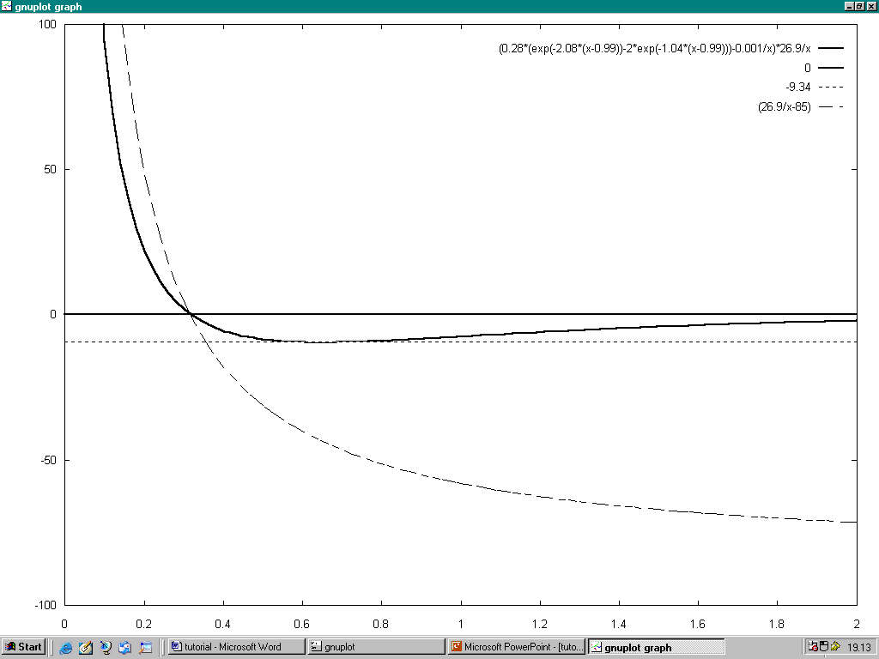
FIG.2

The solid line is shows the features of potential (27) computed using the values reported in table 2. The dashed line the coulomb potential (26). Note they cross the x-axes in the same point. In the x-axes is reported the distance in Bohr radius unit and on the y-axes the energy in eV.

Of course these argumentations are rough, but we believe that they are able to give a reasonable start point.
A better evaluation of point ρ, equilibrium distance and energy disassociation can be obtained from many-body theory. In fact as pointed out in reference [20], the deuteron interaction with the collectives plasmon excitations of the palladium produces a strong attractive potential. This attractive force is due to exchange of plasmons (in the ref. 20 the authors consider only two plasmon excitations at 7.5 eV and 26.5 eV) between two deuteron-lines as reported in figure 3:


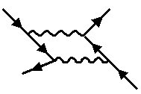
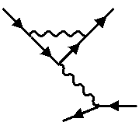
Fig 3. Plasmon exchanges. Solid lines indicate deuterons and wiggly lines plasmons.

Taking into account the role of coupling between deuteron and plasmons, in the ref. 20 the authors have numerically evaluated a d-d potential having the features of potential (26). More exactly in their case ρ is about 0.2 Å, D about 50 eV and r₀ about 1Å.

Table 3
ρ = 0.165 Å | A=0.0001
r₀ = 0.35 Å | r’₀=0.99
D = 50 eV | D’=1.49
D = 50 eV | γ =1.04

In the left column are shown the physical quantities that must characterize the potential (27) where D has been evaluated in reference [20]; in the right the model parameter values that need used in the expression (27) in order to obtain the physical values reported in the left column.

Of course the value of equilibrium distance very strange if compared with the energy dissociation.
But as reported in the ref. 20 this results is due to assumption of un-damped plasmon and the authors declare that “in a more realistic treatment the potential would tend more rapidly to zero”.

For this reason we believe that only the D value is reasonable.
The table 3 shows the new set of parameterization values correspondently to the alternative D evaluation.

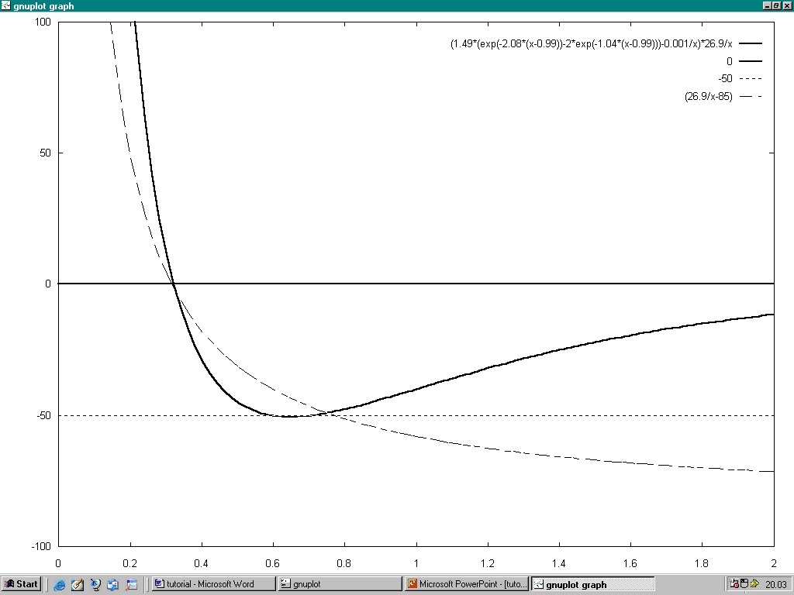
Figure 4

The solid line is shows the features of potential (27) computed using the values reported in table 3. The dashed line is the coulomb potential (26). In the x-axes is reported the distance in Bohr radius unit and on the y-axes the energy in eV.

In the figure 3 is shown the potential (27) evaluated assuming D = 50 eV.
We think that using this effective analytical potential we are able to explore a very large amount of situations that can occur within lattice simply varying the parameterization constant.
Now let us discuss briefly about the role of parameters D’, r’₀ and A.
Of course D’ is the parameter that control the potential well, in fact for D=9.34 eV we put D’=0.28, for D = 50 eV we have D’=1.49. It means that this parameter depends mainly on screening efficiency.
Regarding r’₀ it is clear that it controls the zero crossing point of potential. In fact varying only this parameter the zero crossing point moves according to the increasing or decreasing of r’₀.
It is important to observe that D’ and r’₀ are correlated. In fact it is reasonable suppose that to a bigger potential well correspond a smaller zero crossing point. Taking into account the value reported in fig. 3 we can estimate this rough dependence:

r’₀ =0.35* (50/D’) (30)

Finally, regarding the parameters A, in the pictures shown previously it was put at 0.0001. Moreover we can numerically prove that for small variation (of a factor less than 10) of this value, the potential doesn’t change and its contribute appears relevant only at nuclear distance. Taking into account this observation, we can rewritten this parameter as:

A= HR (31)

where R is about nuclear radius (20 F = 3,76 10⁻⁴ a₀). It means that H= 0.265 eV.
This last value is about equal to the thermal energy of ions palladium that form the lattice [17]. For this reason we are conducted to put H=KT, where K is the Boltzmann constant and T is the lattice temperature.

V. Results and Discussion

A function having a like-Morse trend seems to be the correct potential that is established between two deuterons within a lattice [9,10,20]. The expression (27) proposed in the section IV is an analytical function that have the proper features of a like-Morse potential linked with a Coulomb curve when the inter-nuclear distance approaches to zero.
Using the potential (27) for the two different values of model parameters reported respectively in table 2 and 3, we have computed the d-d fusion rate (the nuclear reaction constant was 10²² sec⁻¹ ). From data shown in table 4 we can see that the fusion rate appears in any case enough ‘great’ or, in other words, ‘measurable’. Moreover these values are in agreement with experimental data reported in the references [15,16,21]. More exactly in the references 15 and 16 has been reported a fusion rate of 10⁻²³ sec⁻¹ for the reaction D(d,p)T, but no significant effect were observed in the neutron and gamma-ray measurements. While in the reference 21 has been reported a fusion rate of about 10⁻²² sec⁻¹ regarding the reaction D(d,n)T.

TABLE 4
A=0.0001 $r_{0}^{'}$=0.99 $D^{'}$=0.28 $γ$=1.04  T(K) = Const E(eV) |  | A=0.0001 $r_{0}^{'}$=0.99 $D^{'}$=1.49 $γ$=1.04  T(K) = Const E(eV)
E ≈ 50 | R ≈ 6.32 * 10⁻¹⁸ | E ≈ 50 | R ≈ 3.02 * 10⁻¹⁶
E ≈ 75 | R ≈ 9.71 * 10⁻¹⁸ | E ≈ 75 | R ≈ 9.12 * 10⁻¹⁷
E ≈ 100 | R ≈ 9.95 * 10⁻¹⁹ | E ≈ 100 | R ≈ 8.2 * 10⁻¹⁷
E ≈ 125 | R ≈ 1.05 * 10⁻²⁰ | E ≈ 125 | R ≈ 1.1 * 10⁻¹⁸
E ≈ 150 | R ≈ 5.6 * 10⁻²¹ | E ≈ 150 | R ≈ 9.15 * 10⁻¹⁹
Fusion rate evaluated using the effective potential for different values of energy and for two different set of model parameters.

Of course in order to better understand this phenomenon, it is necessary distinguish the fusion rate expected by the theory according to the chain reaction, i.e. according to the reaction products expected. This issue has been (partially) clarified by Preparata [17].
Another main question is the following. If the occurrence of cold fusion mechanism is probably due to screening of d-shell electron, is it to possible enhance this effect introducing donor species? These questions will be considered in a next work.
Now let us briefly illustrate as the analytical expression of potential (27) can be extended to better handle the probably role of donor impurities on efficiency of screening.
Since the tunneling is enhanced by screening effect due to d-electron, it is clear that if we dope the lattice by means of donors atoms, the effect of electronic screening is increased. Labeled by J the impurities concentration, we have:

D’ → D’+ GJ (32)

where G is a constant that depends on dopant-metal system.
The other parameter r’₀ will change according to the (31), while regarding A we suppose that in the presence of impurities we’ll can write:

A=JξKT (33)

where ξ is a constant that depends on dopant-metal system.
From a point of engineering view we can compute the new values of formula (32) and (33) measuring the bulk plasmon excitations in function of impurities density, and then following a set of theoretical calculations as which reported in reference [20]. Finally using the potential (27) we will able to evaluate the new fusion rate.
The last point that will be evaluated in an other work is the role of micro-crack. In fact if within a lattice a micro-crack happens a local electrical field takes place that is able to increase the deuteron energy and then according to the values of table 4 is able to enhance the fusion probability.
To conclude, we can say that a cold fusion phenomenon is real. By means of standard theory of many body (see ref. [20]) is theoretically possible aspect fusion rate of about 10⁻²² sec⁻¹, i.e. measurable values. The very strange values of fusion rate as those reported by references [2] and [22] can be considered as errors, but if we take into account other mechanisms as micro-crack formation and/or the role of impurities, may be we will able to understand these spikes and, may be, reproduce them.

References

[1] F. Paneth and K. Peters, Die Naturwissenschaften 43 (1926) 956. English summary in Nature 118 (1926) 526.
[2] M. Fleischmann and S. Pons, J. Electroanal. Chem. 261 (1989) 301.
[3] Y.Iwamura et al., Japanese Journal of Applied Physics A, vol. 41, (1994)
p.4642
[4] O. Reifenschweiler, Physics Letters A, vol. 184, p.149, 1994
[5] O. Reifenschweiler, Fusion Technology, vol. 30, p.261, 1996
[6] H.Melvin Miles et al., Fusion Technology, vol. 25, p. 478, 1994
[7] G.Gamow, Zeitschrift für Physik, vol.51 p. 204, 1928
[8] S.M. Sze and C.Y. Chang, ULSI Technology, McGraw-Hill, 1996
[9] C. DeW Van Siclen and S.E. Jones, J. Phys. G. Nucl. Phys., vol. 12, p. 213, 1986
[10] J.D. Jackson, Phys. Rev. 106 p.330 1957.
[11] L.D.Landau and Lifshitz, Quantum Mechanics, Oxford Pergamon, 1965.
[12] R.E. Langer, Phys. Rev. 51, 669, 1937.
[13] M. Fleischmann and S. Pons, J. Electroanal. Chem. 261, p. 301, 1989.
[14] C. J. Horowitz, Phys. Rev. C, 40, p.1555, 1989
[15] S. Aiello et al., Fusion technology, 18, p. 115, 1990.
[16] K. E. Rehm et al., Phys. Rev. C, 41, p. 45 1989.
[17] G. Preparata, QED Coherence in Matter, World Scientific, 1995
[18] F. Frisone, Fusion Technology, 39, p.260, 2001
[19] O. B. Christensen, Phys. Rev. B, 40, p. 1993, 1989
[20] M.Baldo and R. Pucci, Fusion Technology, 18, p. 47, 1990
[21] Š. Miljianič et al., Fusion technology, 18, p. 340, 1990
[22] S.E . Jones et al., Nature, 338, p.737, 1989.

