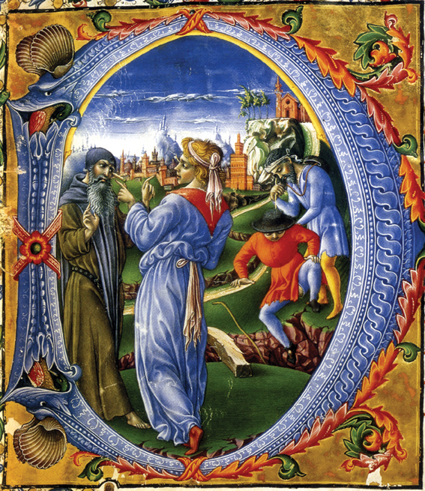
6th International Workshop
on Anomalies in Hydrogen/
Deuterium loaded Metals

Siena, Certosa di Pontignano
Friday 13 May 2005
11:00 Registration (Entrata della Villa)
13:00 Lunch (Sala da Pranzo)
15:00 Oral Presentations (Sala Bracci)
18:30 Round Table Discussion
"Prospects for Radio-active Waste Remediation" (Sala Veranda)
20:00 Dinner (Sala da Pranzo)

Saturday 14 May 2005
09:00 Oral Presentations
11:00 Coffee Break
13:00 Lunch (Sala da Pranzo)
14:30 Excursion to Siena
20:00 Gala Dinner (Sala Caminetto)

Sunday 15 May 2005
09:00 Oral Presentations
11:00 Coffee Break
13:00 Lunch
14:30 Oral Presentations
16:30 Coffee Break
20:00 Dinner (Sala da Pranzo)

Monday 16 May 2005
09:00 Oral Presentations
12:10 Closing Remarks
13:00 Departure

http://www.iscmns.org/siena05/siena.htm

Organizing Committee:
Francesco Piantelli (Siena University)
William Collis (ISCMNS)
Tiziano Ghidini (CEO, Ecodep srl)

Sponsors:
Siena University - Facolta' di Scienze
Matematiche, Fisiche e Naturali.
ISCMNS
Ecodep Srl

