7th International Workshop on Anomalies in
Hydrogen / Deuterium loaded Metals

Ristorante Reale, Piazza Alfieri 5, 14100 Asti, Italy
23-25 September 2006

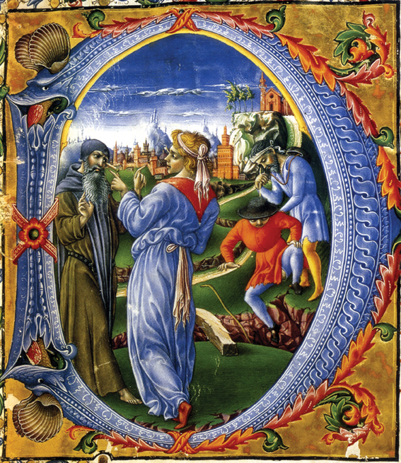

Organizing Committee
William Collis (ISCMNS)
Antonio Spallone (INFN, Frascati)
Vittorio Violante (ENEA, Frascati)
Michael McKubre (Stanford Research Institute)
Jean Paul Biberian (University of Marseilles)
Francesco Celani (INFN, Frascati)

Sponsored by

The International Society for
Condensed Matter Nuclear Science
Ardet nec consumitur

www.iscmns.org/asti06/asti06.htm

